Desktop Tensile Testing Machine

Mechanical Design 2: 2244 MEMS1029 SEC1040

Due Date: 29 March 2024

Group 12: Matthew Bunce, Gabe Noble, Parra Wang, Danijel Babic, Lauren Clapp

# Table of Contents

**Table of Contents 2**

**Technical Summary 3**

**Preliminary Design Proposal 4**

Bill of Materials 4

Theory of Operation: The Upper Gear Train 6

Theory of Operation: The Power Screw Assembly 7

Theory of Operation: The Frame 8

**Technical Analysis 9**

Technical Analysis: Power Screws 9

Technical Analysis: Support Bearings 14

Technical Analysis: Helical Gears 16

Technical Analysis: Stress Analysis on Spur Gears 19

**Summary 22**

**Work Breakdown 24**

# Technical Summary

The proposed tensile testing machine is a compact desktop device designed to assess the mechanical properties of materials through tension testing. Its primary purpose is to subject test specimens to controlled tensile forces while accurately measuring load and displacement. The tensile testing machine is made up of three sections: the upper gear train, the power screw assembly, and the frame. Following the overview, there will be a more detailed analysis of each section. The motor drives the gears, causing the power screws to rotate and, in turn, cause the moving element inside of the frame to translate up and down depending on the direction of rotation. During operation a test specimen will be secured by clamps fixing the bottom of the specimen to the inside of the frame opposite to the gears and motor, and the top of the specimen to the bottom of the moving element. The motor will, through the gear train, transmit a torque to the power screws, which will convert that torque into an axial tension force. The entire machine is shown below, in Figure 1.

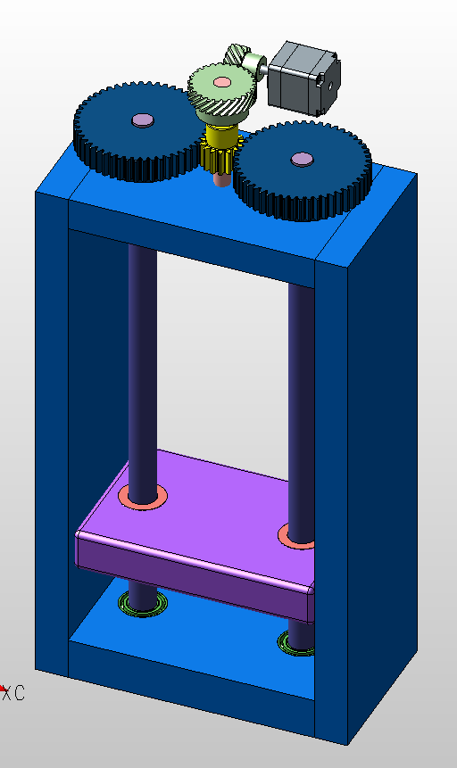

**Figure 1: The Entire Tensile Testing Machine**

# Preliminary Design Proposal

The tensile testing machine will be capable of supplying a tensile force up to 4000 Newtons, will be not overly complicated such that there is more chance of failure in a part, and will be relatively cheap to build.

### **Bill of Materials**

The Bill of Materials (BOM) is given below in Table 1, for each critical component, excluding the frame, motor, and any fasteners. The sections to follow will dissect this BOM and dive into the purpose and analytics into each component.

**Table 1: Bill of Materials**

| **Item #** | **Part** | **Description** | **Part Number**  **\*McMasterCarr unless specified** | **Qty** | **Total Cost** |
| --- | --- | --- | --- | --- | --- |
| 101 | Thrust Washer | 841 Oil Embedded Bronze, 12mm ID, 24mm OD, 2mm THK | 2011N115 | 8 | $17.92 |
| 102 | Needle Roller Thrust Bearing | For 12mm Shaft DIA, 26mm OD, 2200 lbs Dynamic Thrust Load Capacity, 6,500 lbs Static | 5909K12 | 4 | $18.68 |
| 103 | External Retaining Ring | For 12mm OD, 2540 lbs Thrust Capacity (pack of 25) | 90030A101 | 4 | $19.08 |
| 104 | Nut with External Thread | M16 X 3mm Internal, 15/16”-16 X 12” LG External, 75000 psi Tensile Strength | 7549K91 | 2 | $82.20 |
| 105 | Angular Contact Thrust Ball Bearing | 12mm ID, 37mm OD, 2350 lbs Dynamic Load Capacity, 1100 lbs Static Load Capacity | 6680K23 | 2 | $143.60 |
| 106 | Panel-Mount Ball Bearing | For 10mm Shaft Diameter, 24.5mm Spline OD for Press Fit | 1437N25 | 1 | $32.66 |
| 107 | Shaft (A) | 10mm OD, 1045 Carbon Steel, 300mm LG | 1439K311 | 1 | $24.21 |
| 108 | Spur Gear (5,6) | 1.5 Module, 50 Teeth, 75mm Pitch, 1045 Steel | 2664N385 | 2 | $95.18 |
| 109 | Spur Gear (4) | 1.5 Module, 15 Teeth, 22.5 mm Pitch, 303 Stainless Steel | 2664N506 | 1 | $38.96 |
| 110 | Helical Gear (3) | Crossed, 1045 Carbon Steel, 1 Module, 26 Teeth, Right-Hand | 3598N297 | 1 | $26.38 |
| 111 | Helical Gear (2) | Crossed, 1045 Carbon Steel, 1 Module, 13 Teeth, Right-Hand | 3598N290 | 1 | $17.31 |
| 112 | Lead Screw | Precision, M16 x 3mm Thread, 750mm LG, 1018 Carbon Steel, 85000 psi Tensile Strength | 7549K77 | 2 | $109.8 |
| 113 | Motor | 1.02 N-m Continuous Torque, 333 W Power, 4000 rpm Rated Speed | *AeroTech, BM130 | 1 | *Not Included in Cost Estimate |
|  |  | **TOTAL** |  | **29** | **$627.19** |

### To better understand the purpose and location of each component in this proposed design, an exploded view with helpful callouts is included below in Figure 2.

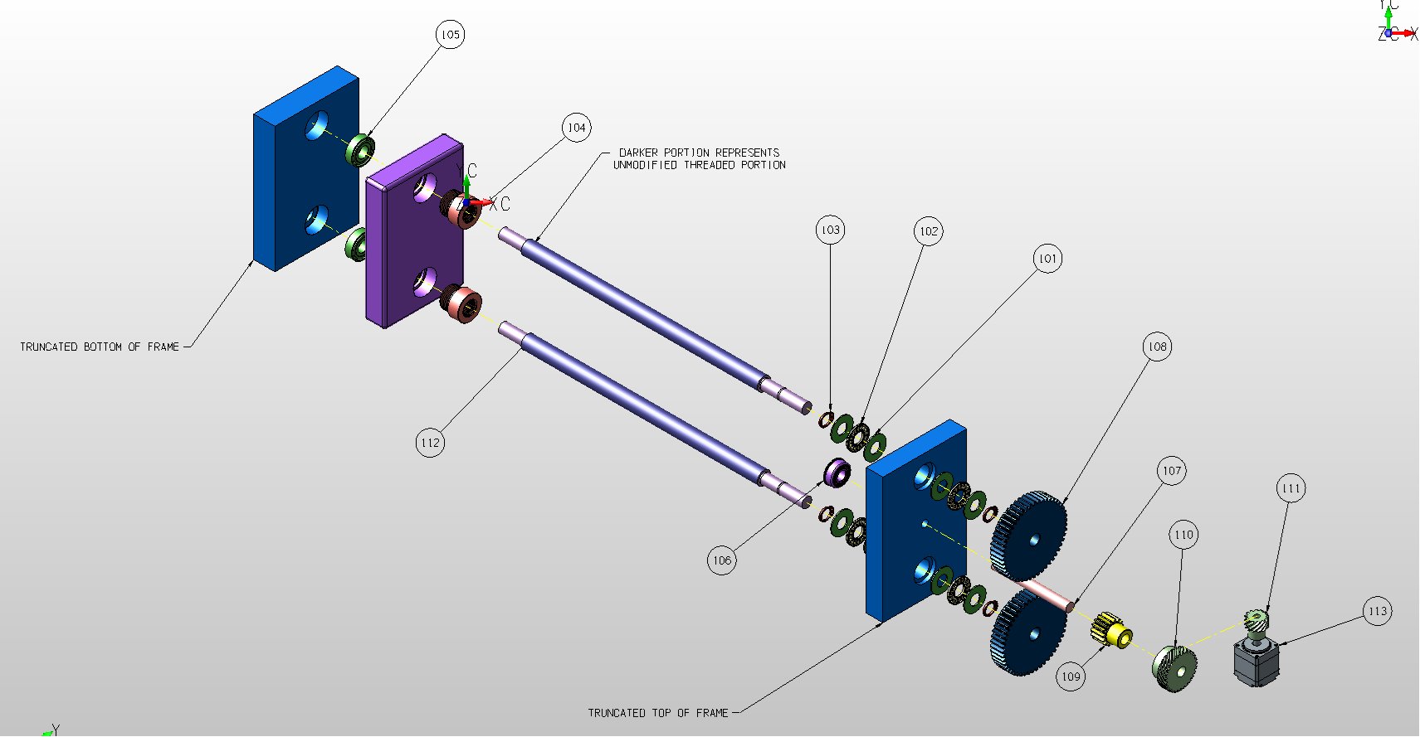

**Figure 2: Exploded View of Preliminary Assembly of the Tensile Testing Apparatus. Note that only the top and bottom plates of the frame are shown for simplicity.**

Figure 2 illustrates the exploded assembly of the tensile tester. In numerous locations, multiple components, such as the lead screws, gears, and frame, will need to be modified in order to fit completely into the final design. These modifications will be thoroughly explained in the following sections, the reader is to note that not all modifications are fully reflected in the computer aided models shown in Figures 1-4.

### 

### **Theory of Operation: The Upper Gear Train**

One is able to analyze the upper gear train most effectively by starting from the output of the motor, then moving down the train. The previously shown Figure 1 provides a helpful visualization of the gear train.

The motor, which is specified to provide a continuous torque of 1.02 N-m and operate with 333 W, will be mounted horizontally to the frame. Helical gear 2 is connected to the output shaft of the motor, which will be interlocked with helical gear 3 on shaft A. Beneath gear 3 on shaft A, spur gear 4 is mounted, and the shaft itself is secured to the top of the frame with the use of the panel-mount ball bearing. This shaft will be attached to gears 3 and 4 through the use of keyways and keys that will provide interlocking features to keep the gears locked both rotationally and axially to the shaft. It will be machined to a smaller diameter at one end, so that the 10mm inner diameter (ID) helical gear and 8mm ID spur gear will be able to be joined together.

The purpose of gear 4 is to provide a means of centralized movement for two other spur gears (gears 5 and 6), located at opposite sides of gear 4, which will turn power screws that will move the stage holding the test specimen.

All gears will be modified in such a way that their inner diameter is compatible with the respective shaft that they are to be mounted to. All gears will have keyways machined into their inner bore as well, which will be the primary method of locking them to the shafts in both the axial and radial direction. The computer aided model of the complete assembly does not illustrate these critical modifications in the interest of simplicity.

### 

### **Theory of Operation: The Power Screw Assembly**

The power screw assembly will consist of two M16 lead screws which will all be driven by the spur gear (5 and 6), which are fixed to the shaft with keyways and keys. The lead screws require multiple modifications for this assembly. The top and bottom of each screw will need to be turned down to a standard diameter of 12mm, allowing the screws to fit through the inner diameter of the gears and bearings. Keyways must be machined in the screws at the gear end, where gears will need to be modified to include keyways. In order to lock the screws from moving axially whilst turning, a series of thrust washers, needle roller bearings, and retaining ring clips will be used. Additionally, multiple roller bearings are necessary to secure the entire lead screw radially. A cross sectional view of the entire assembly is shown below in Figure 3.

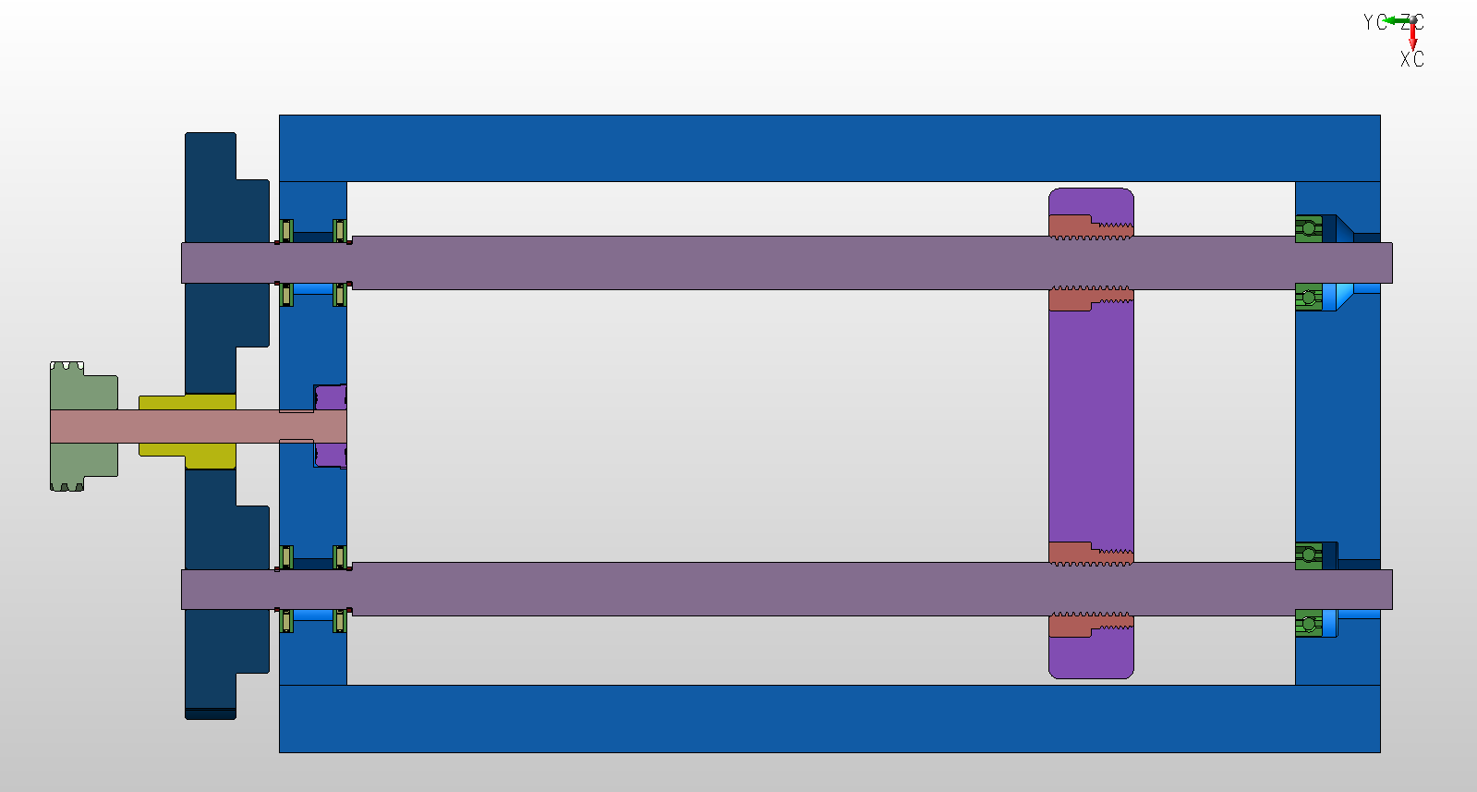

**Figure 3: Cross Sectional View of the Entire Tensile Testing Apparatus. Note that the threads of the lead screws, as well as keys and keyways, are not illustrated in the above image for rendering simplicity.**

Figure 3 gives an insightful look into the necessary modifications to be made on the lead screws. Most notably, at both ends of the shaft, the lead screw must be turned down to a diameter of 12mm, which allows for it to easily fit into multiple standard sized bearings. Additionally, 2 grooves must be machined in each lead screw, for the external retaining ring clips, as seen by the recessed sections on the left side of each screw in Figure 3.

### 

### **Theory of Operation: The Frame**

The frame of the tensile testing machine meets the specifications allowing a 80mm wide specimen to travel 200mm. A simple plate to represent the clamping area of the specimen is used in all computer aided models. As shown in Figure 3 of the previous section, multiple modifications to the frame are necessary to fit in the numerous bearings and other components. The angular thrust ball bearings must be press fit into the bottom of the frame, with through holes large enough to accommodate the 12mmn diameter shaft. Additionally, the top of the plate must be counterbored on both sides to accommodate the item 101-103 assembly, in the interest of a compact design. Figure 4, below, illustrates the important dimensions that ensure these specimen size accommodation requirements.

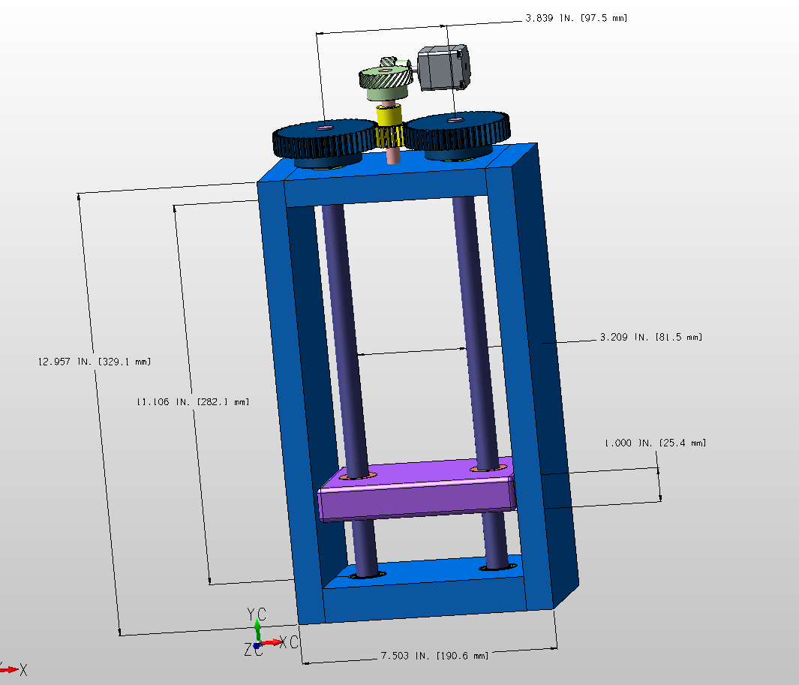

**Figure 4: Important Dimensions of the Frame.**

From Figure 4, we can see that the maximum travel supported by this apparatus is 256.7mm in the Y-direction, and that a specimen up to 81.5mm wide can fit between the lead screws. Additionally, the frame itself is 329.1mm tall and 190.6mm long, and can be extended to any desired width (in reason) with no complications to the following analyses. A single purple plate with two externally threaded nuts is illustrative of the location of a specimen clamping apparatus, which would be further developed after this preliminary design is approved. Finally, a mounting plate subassembly for the motor is not shown, and would be necessary for final operation.

# Technical Analysis

In this section, we will analyze the main components of our design which include the power screws, support bearings, helical gears, and spur gears.

### **Technical Analysis: Power Screws**

We completed the following calculations (Equations 1-14) for a variety of screw sizes, and determined that the most ideal lead screw dimension is an M16 screw. The calculations that follow assume these dimensions.

For an M16 screw, the nominal diameter, d is 0.016m and the threaded pitch, p is 0.003m. Additionally, we chose a bolt length of 0.7m.

The root diameter, calculation is shown below, in Equation 1.

(1)

The lead, calculation is shown below, in Equation 2.

(2)

*where, n = number of threads*

The mean diameter, calculation is shown below, in Equation 3.

(3)

We can use Equations 1, 2, and 3 to find the critical dimensions for the lead screw which we plan on using.

These dimensions are neatly described in Table 2.

**Table 2: Dimensions of M16 Power Screw**

| Bolt total length [m] | Lead Screw Diameter [mm] | Lead Screw Mean Diameter, *Dm* [m] | Lead Screw root Diameter, *Dr* [m] | Axial pitch, *p*  [m] | Lead, *l* [m] |
| --- | --- | --- | --- | --- | --- |
| 0.7 | 16 | 0.0145 | 0.013 | 0.003 | 0.003 |

For our situation, we use the assumed force of 2000N per lead screw, since we are using two lead screws to withstand a maximum expected force of 4000N. We can also assume the coefficient of friction is 0.15 as long as we ensure that it is properly lubricated (*Shigley’s Mechanical Engineering Design, 10th Ed.*, *pg. 414)*.

Torque required to raise the load, is seen below, in Equation 4. Where F is the external force, is the major diameter, is the coefficient of friction, and is the lead of the power screw.

(4)

Torque required to lower the load is seen below, in Equation 5. If , then the power screw is self locking, which is what we desire in our design.

(5)

Two depictions of free body diagrams for the lead screws raising and lowering a load are shown below, with the force being raised depicted in Figure 5, on the left, and the force being lowered depicted is on the right.

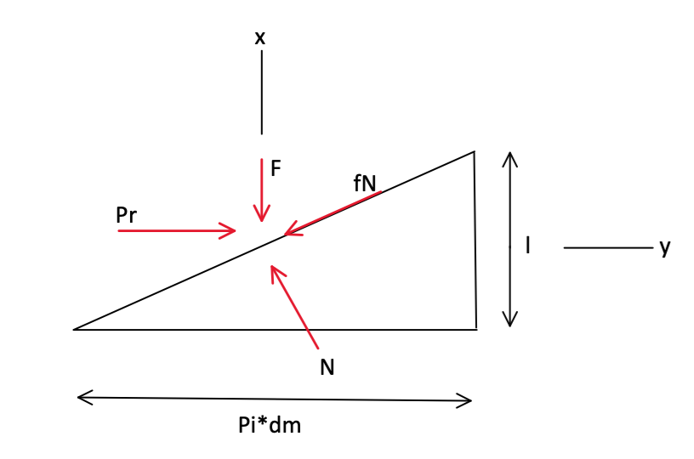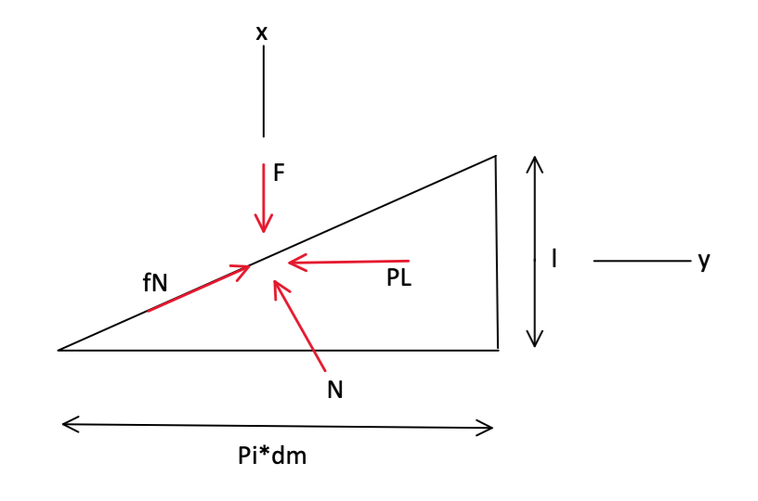

**Figure 5: Lead Screw Raising Load (left) and Lead Screw Lowering Load (right)**

We can use Equations 4 and 5 to analyze our lead screw with the dimensions from previous steps.

The tensile stress per screw, is in Equation 6.

(6)

For our screw size, it is known that = 157 mm2 . With this in mind, we can use Equation 6 to calculate the tensile stress.

One can find a description of force, torques required to raise and lower the load, and tensile stress values for our M16 bolt explicitly described in Table 3.

**Table 3: Forces and Torques Experienced by each Power Screw**

| F [N] | [-] | [mm2] | TR [N-m] | TL [N-m] | 𝝈t [MPa] | Self locking? |
| --- | --- | --- | --- | --- | --- | --- |
| 2000 | 0.15 | 157 | 3.161 | 1.208 | 12.739 | Yes |

The overall efficiency in raising the load, calculation is shown below, in Equation 7.

(7)

The body shear stress, due to torsional moment, at the outside of the screw body calculation is shown below, in Equation 8.

(8)

The axial nominal stress, calculation is shown below, in Equation 9.

(9)

The bearing stress, with one thread carrying 0.38F is calculated below, in Equation 10. This assumption is made because the highest load a thread experiences is approximately 0.38 of the total force experienced, which occurs on the first thread (This fact comes from *Shigley’s Mechanical Engineering Design, 10th edition, page 411).*

(10)

The thread root bending stress, with one thread carrying 0.38F is calculated below, in Equation 11.

(11)

In our situation, Equations 7-11 can be calculated as:

In order to determine the Von Mises stress, we can find the three dimensional stresses of the bolt. We can note that there is zero transverse shear at the extreme root of the cross section of the bolt. These three dimensional stresses, with coordinate *y* into the page are,

The principle stresses can be calculated with Equation 12 below, noting that there are no shear stresses on the x face, making an additional principal stress (.

(12)

The Von Mises stress is calculated below, in Equation 13.

(13)

The maximum shear stress is calculated below, in Equation 14.

(14)

The calculations of Equations 12-14 in the context of our power screw dimensions and forces are shown below, and are tabulated in Table 4. For the bolt we chose, the ultimate strength is 341 MPa.

**Table 4: Von Mises Stress, Max Shear stress**

| Ultimate Strength of bolt [MPa] | [MPa] | [MPa] |  | FoS |
| --- | --- | --- | --- | --- |
| 341* | 46.615 | 27.631 | 0.8056 | 7.32 |
| *Found in Shigley’s Mechanical Engineering Design, Table A-22 | | | | |

It is necessary to analyze the power screw compressive loadings to ensure no buckling of the bolt will occur. The Euler Formula can be used to estimate the critical load at which buckling will occur for relatively long screws of column length and the second moment of area:

(15)

(16)

*where C is the Buckling End-Condition Constant, and E is the Young’s Modulus.*

Therefore, we can rewrite the Equation in terms of :

(17)

Since our lead screw is fixed by the collar bearings and externally threaded ball bearings on the lifting block, we use C=4 for our end-condition constant, which is the fixed-fixed condition from *Shigley’s Mechanical Engineering Design, 10th Ed*., pg 197.

The lead screw is made of 1018 Carbon Steel which has a Young’s Modulus, E, equal to 186GPa. Therefore, we can find the column length where the critical force reaches 2000 N:

We can find that when the length is larger than 2.27 m, applying 2000 N on each of the lead screws will cause them to buckle. However, our lead screw has a thread length of 0.2 m and an overall length of 0.75 m. The critical length is much longer than this, so we do not have to worry about the lead screws buckling.

### **Technical Analysis: Support Bearings**

The roller bearings within our system allow rotation about one axis, while restricting the movement in the other axes. This is necessary in locations such as where the power screws and other shaft make contact with the frame of the tester frame. Analyzing the roller bearings within our system will allow us to find the bearing lifetime in the context in which they are used. In this system, there are a total of 2 needle roller thrust bearings per lead screw, 1 thrust ball bearing per lead screw, and 1 panel mounted ball bearing.

The reliability of a bearing can be calculated with Equation 18 below.

(18)

*where is a simplified reliability scale compared to number of bearings used, is the manufacturer’s dynamic load rating, and F is the axial load experienced*.

The bearings are assumed to rotate a maximum of 1 million times during their life if they are constantly operating at their specified dynamic load rating, so a factor of is applied.

The needle roller thrust bearings are required within the lead screw assembly in order to act as a low friction contact point for the lead screw and the frame so that the screw is able to rotate freely. For each lead screw, there will be 2 needle roller thrust bearings in use.

We can assume that the bearings only experience an axial thrust force of 1000 N each, since there are 4 of such bearings in the assembly. Additionally, the speed of the shaft which this is attached to (along with gear 5 or 6) is 48.97 rad/s or 467.6 rpm. For this case, we will ignore the weight of the shaft and gears above them because they are nearly negligible compared to the large force of the power screw itself. In this situation, = 0.62, and would bring the reliability to 95%. The manufacturer dynamic load rating, for this particular bearing is 9789.43 N. Using Equation 18, we can calculate the lifetime of the needle roller thrust bearings.

The thrust ball bearing is required in the assembly for a similar purpose as the needle roller thrust bearing, except in this case to act as an interface between the spinning lead screw and the base of the tensile tester. For each lead screw, there will be a total of 1 thrust ball bearing in use.

We can assume that the bearings experience an axial force of 2000 N each, since there are 2 of such bearings in the assembly. The speed of the shaft which this is attached to is 48.97 rad/s or 467.6 rpm. We will ignore the weight of the shaft of this bearing as well for the same reason as the needle roller thrust bearings. In this situation, there is only one bearing in use for the analysis, so = 1.0 and reliability is 90%. The manufacturer dynamic load rating, for this particular bearing is 10456.89 N. Using Equation 18, we can calculate the lifetime of the needle roller thrust bearings.

The final bearing which will be used in this design is the panel mounted ball bearing. These bearings are required within the gear assembly in order to act as a low friction contact point for shaft A, which connects the sun gear to a fixed point, and is mounted to the top of the frame. There will be 1 panel mounted ball bearing in use.

The only axial force which this bearing will experience will be from the weight of the components which it will hold above the frame, so we will not be able to ignore this in this instance. Using the density of steel, which is 7870, and the volume of each of the components, one is able to find a conservative estimate of force for these components, which is about 12.61 N. The speed of the shaft which this is attached to is 163.24 rad/s or 1558.8 rpm. In this situation, there is only one bearing in use for the analysis, so = 1.0 and reliability is 90%. The manufacturer dynamic load rating, for this particular bearing is 533.96 N. Using Equation 18, we can calculate the lifetime of the needle roller thrust bearings.

The results of each bearing is shown in Table 5 below.

**Table 5: Support Bearing Analysis**

| **Bearing Type** | **Number Used Per Use Case** | **Axial Load, Fa [N]** | **Speed [RPM]** | **Dynamic Load Rating [N]** | **Lifetime [rev]** | **Lifetime [hrs]** |
| --- | --- | --- | --- | --- | --- | --- |
| Needle Roller Thrust Bearing | 2 | 1000 | 649.49 | 9789.4304 | 1.88E+09 | 66872.00 |
| Thrust Ball Bearing | 1 | 2000 | 649.49 | 10456.8910 | 1.43E+08 | 5094.01 |
| Panel Mount Ball Bearing | 1 | 12.61 | 1,558.78 | 533.9691 | 7.59E+10 | 812019.84 |

### 

### **Technical Analysis: Helical Gears**

To assess the factor of safety for a helical gear, it is essential to calculate the bending stress experienced by the gear tooth. Specifically, for helical gear 2, which possesses 13 teeth, has a module of 1 mm, and has a pitch diameter of 18 mm, the relevant parameters include a pressure angle of 20 degrees and a helix angle of 45 degrees. Helical gear 3 is of the same type as gear 2, but it has 26 teeth and a pitch diameter of 36 mm. Although the Lewis formula is traditionally used for spur gears, it can be adapted with slight modifications to offer a preliminary conservative estimate of the bending strength of helical gears.

(19)

(20)

*where: = Pressure angle; β = Helix angle; σ = Tooth Bending stress (MPa);F = Face width (mm); Y = Lewis Form Factor; m = Module (mm)*

Figure 6 below shows data corresponding to different parts and the forces on them (a comprehensive Table will be provided at the end of this analysis).

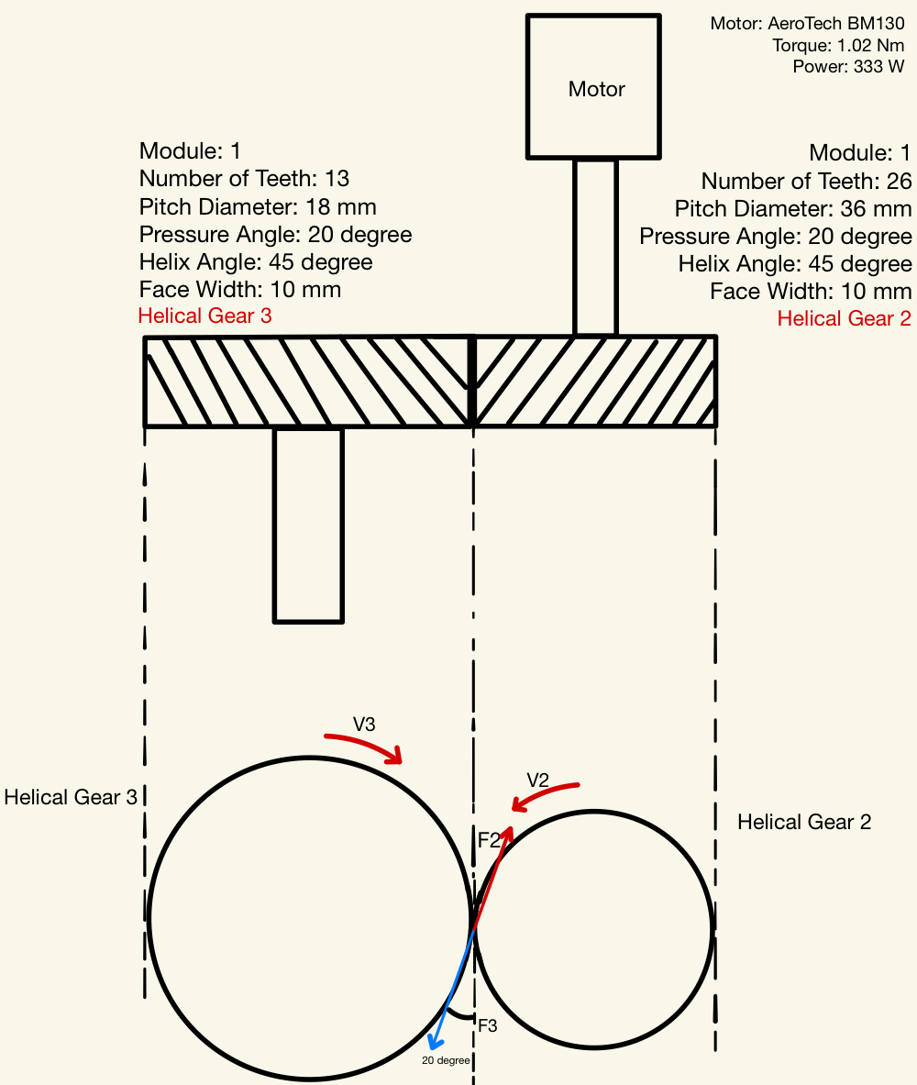

**Figure 6: Helical Gear Free Body Diagram**

The method used to analyze each set of gears was a systematic approach using gear geometry and force analysis. As an example of this process, one may look at helical gear 2 within the free body diagram shown in Figure 7 with the various components labeled appropriately.

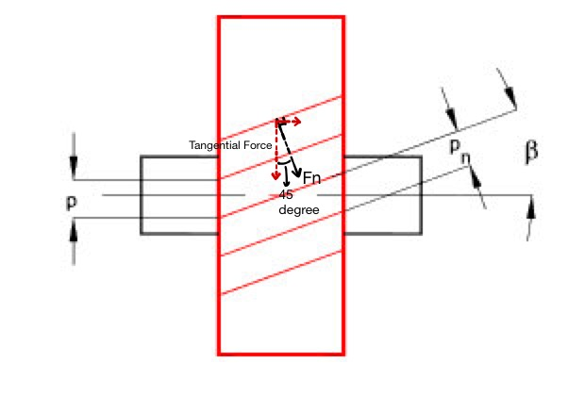

**Figure 7: Helical Gear 2 Free Body Diagram**

Because the pressure exerted on a surface is perpendicular to it, we can calculate the normal force using the tangential force and the helix angle.

For , we use the hobbed and shaped profile, and the Barth Equation gives Equation 21.

(21)

V is the pitch line velocity, defined by Equation 22:

(22)

According to the geometry in Figure 7, we can find the tangential force using Equation 23.

(23)

As Figure 7 shows, the Equation for normal force can be derived as Equation 24.

(24)

With the teeth ratio of the mating gears, we can determine the angular velocity of gear 3 which is given as Equation 25.

(25)

Since we know that the torque the motor provides continuously is 1.02 Nm, we can find the tangential force according to the relationship in the diagram. T is the torque provided by the motor and P is the pitch diameter of helical gear 2. The tangential force is given by Equation 23:

Then, we can find using Equation 24, *V2* using Equation 22, and using Equation 19.

With the same process, we can find the bending stress on the helical gear 3. Since two helical gears are mated, the speed and force on the pitch line are the same. In that case, we need to use the Lewis Form Factor for 26 teeth to calculate the bending stress which is given below.

If we assume the efficiency of the gear train as 95%, we can find the torque on the helical gear 3, seen below.

Table 6 below shows a detailed analysis of each helical gear.

**Table 6: Helical Gear Analysis**

| Helical Gear | Module (mm) | # of Teeth | Pitch Diameter (mm) | Pressure Angle (degree) | Velocity (rad/s) | Torque (Nm) | Yield Strength(MPa) | Bending Stress (MPa) | FoS |
| --- | --- | --- | --- | --- | --- | --- | --- | --- | --- |
| 2 | 1 | 13 | 18 | 20 | 326.47 | 1.02 | 450 | 96.83 | 4.65 |
| 3 | 1 | 26 | 36 | 20 | 163.24 | 1.94 | 450 | 73.04 | 6.16 |

### **Technical Analysis: Stress Analysis on Spur Gears**

Under the helical gears is a shaft connected to a spur gear 4 which is mated with another two spur gears 5,6, driving the lead screw to rotate. Since speed is cheap and torque is expensive, the main idea of this gear train is to increase the torque with the increasing number of teeth on the gears which is also applied to the helical gear part. Below, in Figure 8, is the lower part diagram of the gear train and information about these gears (A comprehensive Table will be provided at the end of this analysis).

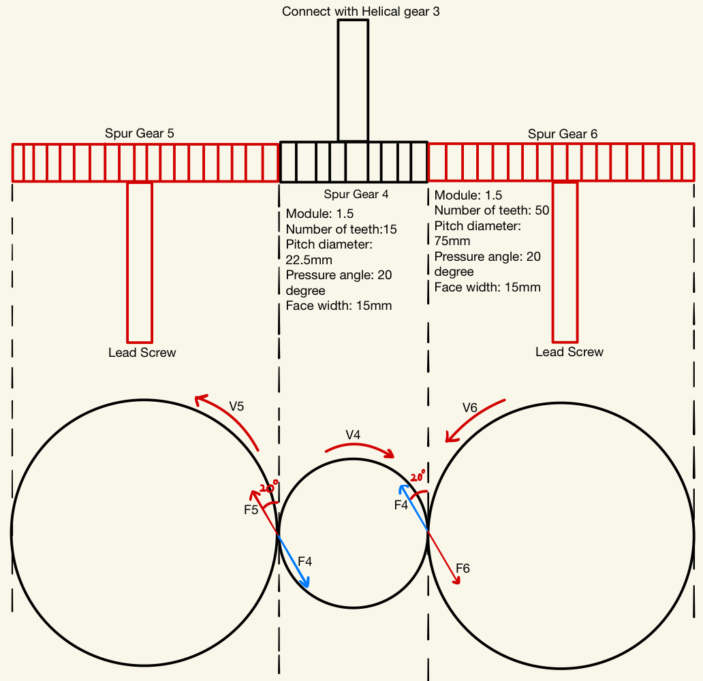

**Figure 8: Free Body Diagram of Lower Gear Train**

According to the previous analysis, we already know that the angular velocity of helical gear 3 is which is the same as the angular velocity of spur gear 4 since they are connected with the shaft. To begin the stress evaluation on spur gear 4, we will use the Lewis Equation to find the maximum stress on a gear tooth, shown in Equation 26.

(26)

is the dynamic factor for SI units and a cut or milled profile, as defined by Equation 27 below.

(27)

Since we know that the angular velocity of helical gear 3 is which is the same as the angular velocity of spur gear 4, we can find the for spur gear 4:

According to the geometric relationship in the diagram above, the relationship given in Equation 28 is apparent.

(28)

With the efficiency of 95%, the power of the gear 5 and 6 is given as Equation 29.

(29)

According to the data from gear 4,5 and 6, we can find the angular velocity which is given as Equation 30.

(30)

In the end, with the power and angular velocity we obtained from the last two Equations, we can find the torque which is shown below in Equation 31.

(31)

The force acting on the gear can be found with Equation 32.

(32)

We assume 95% efficiency for this gear train since the energy loss in a helical and spur gear train is usually low. In that case, we can determine the power for both spur gears 5 and 6:

With the ratio between gears, the angular velocity of spur gears 5,6 is found, along with the torque and force applied to gears 5 and 6. Additionally, we can determine *F4*, ,, , and *T4*, as seen in the below sequence.

Table 7 shows the detailed analysis for each spur gear.

**Table 7: Spur Gear Analysis**

| Gear # | Module [mm] | # of Teeth | Pitch Diameter [mm] | Torque [N-m] | Velocity [rad/s] | Yield Strength  [MPa] | Bending Stress [MPa] | FoS  [-] |
| --- | --- | --- | --- | --- | --- | --- | --- | --- |
| 4 | 1.5 | 15 | 22.5 | 1.94 | 163.24 | 415 | 16.13 | 25.73 |
| 5 | 1.5 | 50 | 75 |  |  | 450 | 11.43 | 39.37 |
| 6 | 1.5 | 50 | 75 |  |  | 450 | 11.43 | 39.37 |

# 

# Summary

The operation of our desktop tensile tester design is contingent upon the performance of a gear train, power screws, and bearings. Overall, the design is capable of safely generating and withstanding 4000N while maintaining a reasonable lifetime.

The power screws generate tension force by converting the rotational movement of the shaft into the translational movement of the moving element. This element holds the test specimen in place. Given that our design uses two lead screws, each lead screw needs to generate 2000 N to meet the requirement of delivering a maximum force of 4000 N. If we assume a reasonable friction coefficient, Equation 4 allows us to compute the torque that must be delivered to any power screw with a known nominal diameter, pitch, and lead to generate this force. For an M16 lead screw, the torque required to raise the lead screw against the 2000 N load is 3.161 Nm, and can be observed in Table 3.

This required torque is larger than the torque delivered by our motor, which only generates 1.02 Nm. In order to make up for this difference, we use a gear train to multiply the torque delivered to the power screws. We assume a 95% efficient transmission of power across the entire gear train, meaning that the power transmitted to gears 5 and 6 is 95% of the power generated by the motor, divided in half since there are two output gears. This relationship is shown in Equation 29 and gives us a power of 158.2 W. Equation 31 shows that the torque on gears 5 and 6 can be calculated if we know their speed. The speeds of all the gears are obtained by finding the transmission ratios between them, which can be found by examining the number of teeth on meshing gears. We can use Equation 25 to find that the angular velocity of gear 3, and therefore gear 4, is 163.2 rad/s. Table 7 gives the values used in these calculations. Similarly, we can use Equation 30 to find the angular velocity of gears 5 and 6 to be 48.97 rad/s. We can finally plug this value and the power transmitted to each gear into Equation 31 to find that the torque output of gears 5 and 6 to be 3.23 N-m each, which is greater than the required torque to rotate each lead screw against the 2000 N load. These values can be found in Table 8.

Our design has three major failure modes: power screw failure, bearing failure, and gear failure. We need to make sure the power screws do not experience excessive stress or buckling. We can check the maximum stress expected in each power screw by finding the von Mises stress caused by tensile stress, thread root bending stress, and the body shear stress due to torsion. Equations 7 through 14 correspond to these calculations. The von Mises stress comes out to 46.6 MPa, leaving a factor of safety of 7.32. These values can be seen in Table 4. In order to make sure the power screw doesn’t buckle, we use the Euler buckling formula to determine the critical length at which our power screw could buckle. Using Equation 17, we find that the critical length is 2.27m, which is much larger than our 0.75m long power screws; we don’t have to worry about our power screws buckling.

Since we use a total of seven bearings in our design, we need to make sure that they have a reasonable lifetime so they do not fail due to fatigue. Equation 18 lets us compute the expected lifetime for each of our bearings, given their dynamic load ratings, reliability level, and experienced axial force. Since we use two needle roller thrust bearings on each power screw, we calculate their 95% reliability lifetime and calculate the 90% reliability lifetime of the other two bearing types. The lowest estimated lifetime is 5094 hours for the thrust ball bearings, which we consider reasonable; if one tensile strength test takes a minute, over 300,000 tests can be carried out.

Finally, to ensure that our design works safely, we need to make sure our gears aren’t overstressed. The Lewis formula for gear stress, shown in Equation 19 (modified for helical gears) and 26, lets us calculate the maximum bending stress that any gear will undergo. Since we picked out the gears from McMaster-Carr, we can find the physical parameters like face width and module for each gear by looking up their part number (found in the BOM) on McMaster-Carr’s website. We can find the force on any given gear by dividing the torque that it experiences by its pitch radius, as illustrated in Equation 32. The final values for the bending stress experienced by each gear can be found in Table 7 (helical gears) and Table 8 (spur gears), as well as each of their factors of safety. The lowest factor of safety is 4.65, associated with gear 2; this is high enough that there is no concern that any of the gears will fail.

Our design uses two power screws to create a tensional load of 4000 N on a test specimen by using a gear train to induce a large torque on each power screw, powered by a motor. The power screws will not buckle and will not fail due to being overstressed. The bearings that allow the power screws and gear shafts to spin with low friction are very unlikely to fail even after hundreds of thousands of tension tests. The stresses experienced by the gears in our design are far below their yield stresses. Overall, our design is powerful, sturdy, reliable, and has a very low cost.

# 

# Work Breakdown

Table 9 below shows the contributions from each team member that demonstrates adherence to the objective and allocated time budget of about 10 hours per person.

**Table 9: Total Hours Logged**

| **Name** | **Total Hours** | **Activity** |
| --- | --- | --- |
| Lauren | 10 | CAD, Report |
| Parra | 10 | Shaft Buckling, Gear Design, Report |
| Matthew | 8 | Lead Screws, Gear Design, Report |
| Gabe | 15 | CAD, Lead Screws, Gear Design, Report |
| Danijel | 12 | Lead Screws, Bearings, Report |